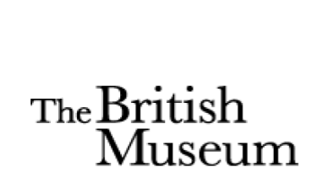

International Training Programme: Summer Programme 2020
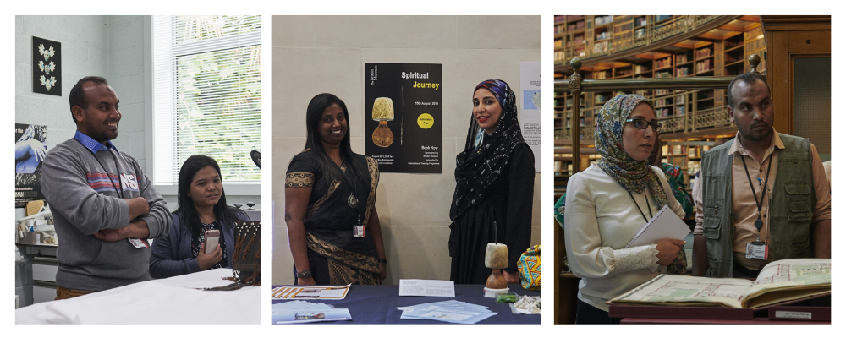

Application Form

The 2020 International Training Programme will take place from Saturday 4thJuly to Saturday 15th August.

Please complete this form giving us as much detail as you can, to a maximum of 200 words per question.

To find out more about the British Museum’s International Training Programme, please see the links below:

ITP Website: http://www.britishmuseum.org/about_us/skills-sharing/international_training.aspx
ITP Blog: https://bmitpglobalnetwork.org/
ITP Facebook Group: https://www.facebook.com/groups/BMITP/#
ITP Email Address: itp@britishmuseum.org
ITP Twitter Account: @britmusitp
ITP Instagram Account: @britmusitp

Please return this form to itp@britishmuseum.org by the end of Sunday 23rd February 2020.

If you have any questions or queries, please do not hesitate to contact to contact Anna Cottle (acottle@britishmuseum.org) or Claire Messenger (cmessenger@britishmuseum.org) - we will be happy to give any help and advice.

International Training Programme 2020
Application Form

Title:- | Dr/Mr/Mrs/Miss/Ms
Forenames:-
Surname (Family name):-
Gender:- | Male/ Female
Nationality:-
Present home address:-
Job title:-
Institution:-
Current work address:-
Work telephone number:-
Home telephone number:-
Mobile telephone number:-
E-mail address:-

Present job description:-
Please write 200 words about your responsibilities and day-to-day work.

Museum interests:-
Please write 200 words on the museum areas you would be interested in learning more about during the ITP (for example Exhibitions, Education, Fundraising, Conservation, Marketing, Photography, Security, Collections documentation, Storage, Libraries & archives, etc.)

You can visit the British Museum website: http://www.britishmuseum.org/ for ideas of the different Departments, what they do, and which ones may be appropriate for your aims during the ITP.

Research interests:-
Please tell us about your research interests and any projects you are currently working on.

Please note that this is not a research programme. If your main interest is research, we suggest you apply for a separate research visit.

Goals:-
What would be your specific goals for your time at the British Museum, professionally & personally?
What would you like to gain from the programme?

What are your hopes and goals for your museum/heritage sector over the next 10 years?

Your home institution:-
Does your institution/manager have any specific issues they would like you to address through this training programme?

How would you use your experience of the ITP to benefit your work and institution?

Working internationally:-
What do you feel are the benefits and challenges of working internationally?

Is there any further information that you would like to include?
For example, the ITP is a ‘skill-sharing’ programme, what could you bring to the ITP as a participant?

References:-

Please provide the names and contact details of two people whom we may contact as referees to comment on your suitability to undertake the training placement at The British Museum. We would like one referee to be from your current employment – your Director or manager. The other referee can be a colleague, friend, doctor or teacher but not a family member.

To the best of my knowledge the answers given to the questions contained in this personal details form are true and accurate. Any falsification may be considered sufficient cause for rejection from the International Training Programme.

Signature:-
Name (Printed):-
Date:-

