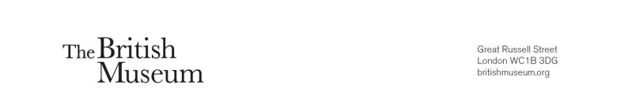

International Training Programme
ITP Leadership week
29 October - 6 November 2022

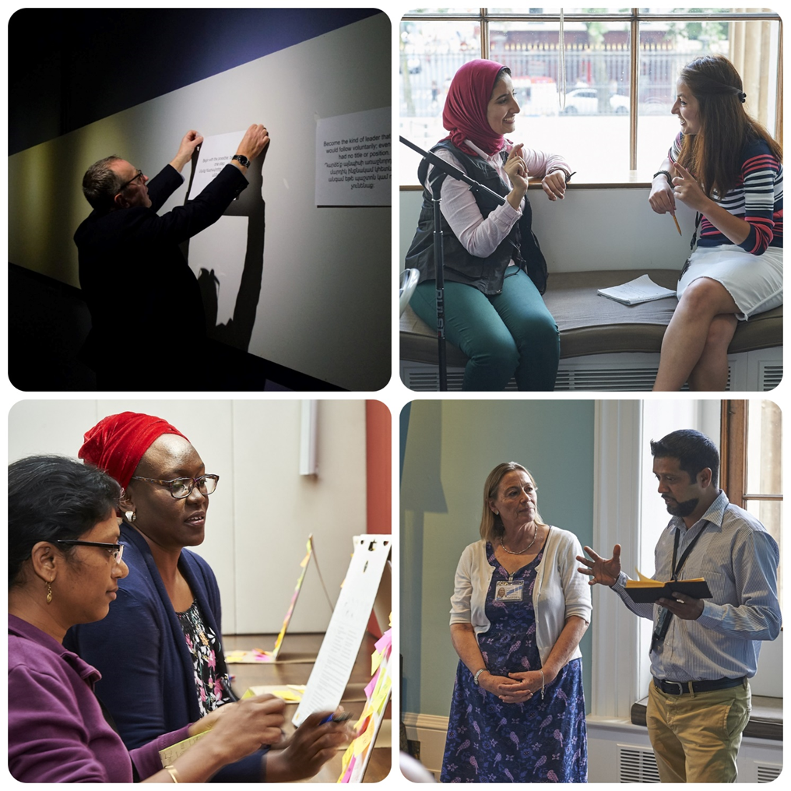

Application Form

Please read the accompanying advert carefully and complete this form giving us as much detail as you can, approximately 200 words per question.

Please return this form to itp@britishmuseum.org by midday on Friday 25 March 2022.

If you have any questions or queries, please do not hesitate to contact to contact Anna Cottle (acottle@britishmuseum.org) or Claire Messenger (cmessenger@britishmuseum.org) - we will be happy to give any help and advice.
International Training Programme Leadership week
29 October - 6 November 2022
Application Form

Title:- | Dr/Mr/Mrs/Miss/Ms
Forenames:-
Surname (Family name):-
Nationality:-
Present home address:-
Job title:-
Institution:-
Current work address:-
Work telephone number:-
Home telephone number:-
Mobile telephone number:-
E-mail address:-

ITP History:-

Which year did you attend the ITP Summer Programme?
Have you applied for an ITP legacy project before?
If yes, which?
Was the application successful?
Examples:
Conferences (Cairo 2010, Mumbai 2015, Uppsala 2016, Leicester 2016, Glasgow/Bristol 2016, Yerevan 2016, Manchester 2017, Belfast 2018, Brighton 2019)
BM Empire Symposium 2018
ITP+ course (May 2017, December 2017)
ITP+ Aswan 2018
ITP+ Mumbai 2019
ITP Futures 2020
Senior Fellow
Collaborative Award
Dresden Fellowship

Present job description:-

Please tell us about your current responsibilities and day-to-day work. Please use this as an opportunity to highlight your leadership experiences.

As an ITP Fellow how has your experience of the summer programme helped you shape your professional work and career? Please provide three examples. One example should relate to your experiences of leadership and management.

What do you see as the difference between a manager and a leader? Please provide three examples.

What kind of leader are you – or would you like to be?

Why does this opportunity interest you?

The Museum Association conference 2022 will look at the following crucial issues, including the climate crisis, inequalities and racism, the legacy of empire, and wellbeing.
What do you feel you can gain professionally from attending the conference?

This event will be an ideal opportunity to engage with fellows from the ITP global network and the wider museum sector. How do you plan to make the most of this opportunity for networking? What benefits can you see for you and your institution? Please give specific examples.

What specific plans do you have for applying the knowledge, skills and experience gained from this opportunity once you get home?

Is there any further information that you would like to include to support your application?

Please confirm that your employers (institution and manager) are happy for you to attend
this course from 29 October - 6 November 2022.
Please tick to confirm either:
Yes ____ No _____

To obtain a visa for travel, your passport must be valid for 6 months after the dates of travel.
In this case, until 6 May 2023.
Please tick to confirm either:
a) My passport is valid beyond 6 May 2023 ____
b) I am aware that if I am accepted for the conference, I will need to renew my passport immediately ____

To the best of my knowledge the answers given to the questions contained in this personal details form are true and accurate. Any falsification may be considered sufficient cause for rejection from the application process.

Signature:-
Name (Printed):-
Date:-

Please return to:-
International Training Programme
E-mail: itp@britishmuseum.org

