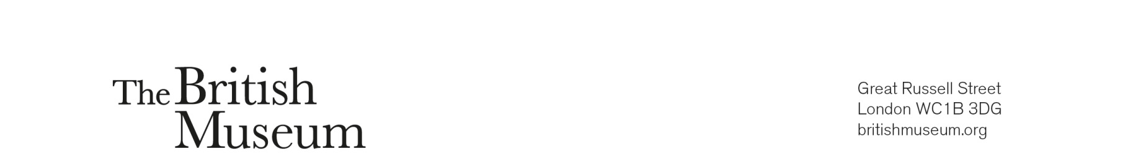

International Training Programme
ITP Collaboration Grants 2026

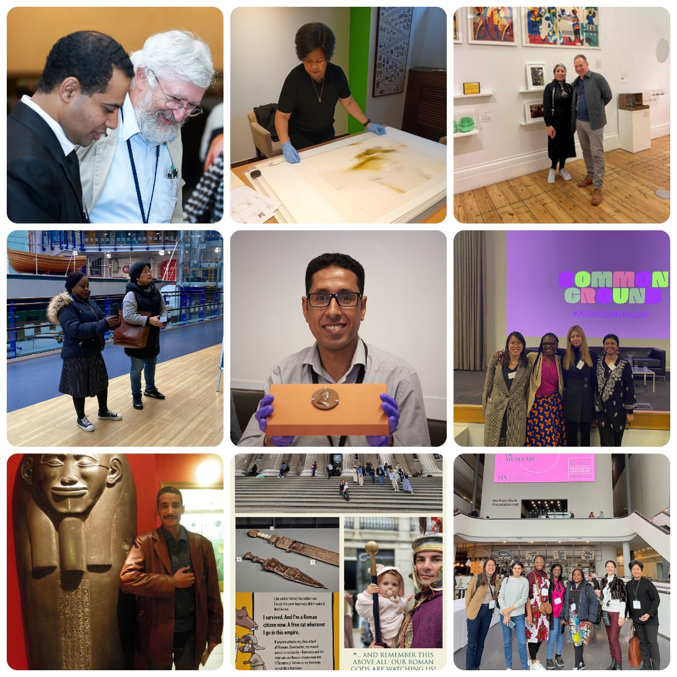

Please read the supporting guidance information document before completing this application form.
For any questions, please contact Amelia Kedge, ITP Coordinator (Legacy Projects) directly at akedge@britishmuseum.org.
ITP Collaboration Grants 2026
Application Form
Part 1 – personal details
Participant 1 – lead contact
Title: | Dr/Mr/Mrs/Miss/Ms
Forenames:

Surname (family name):

Nationality:

ITP year
Job title:

Institution:

Current work address:

Email address:
Work telephone number:
Mobile telephone number:

Present job description
Please tell us about your current responsibilities and day to day work.
Maximum 250 words.

Participant 2
Title: | Dr/Mr/Mrs/Miss/Ms
Forenames:

Surname (family name):

Nationality:

ITP year (if applicable)
Job title:

Institution:

Current work address:

Email address:
Work telephone number:
Mobile telephone number:

Present job description
Please tell us about your current responsibilities and day to day work.
Maximum 250 words.

Please repeat this section for any additional collaborators.
Part 2 – project details
Project title

Project start and end dates

Project location(s)
- Where will the project be based?
- Will there be any travel involved? If so, where?

Please name all participating individuals and institutions

If selected, you will need to confirm that all participating institutions have given their permission for this project to go ahead.

Please give a short description of your collaborative project.
Max. 250 words

What are the main aims of the project, and what do you hope to achieve through this collaboration?
Max. 250 words

Please explain how this project supports your professional development and responds to your current institutional or professional goals.
Max. 250 words

Please describe how you will work collaboratively with your project partners, including roles, responsibilities, and methods of communication.
Max. 250 words

Why is collaboration essential to this project, and how does it strengthen the outcomes?
Max. 250 words

What tangible outcomes will result from the project (e.g. toolkit, digital resource, case study, workshop, film). And how will these be shared with the ITP network?
Max. 250 words

Please provide a brief project timeline, including key milestones.
All projects must be completed by 1 December 2026

Part 3 – funding details
We will provide up to £3000 GBP for you to carry out the collaboration project proposed.
All costs which will be included | Approximate costs with link to supporting estimates
Grant transfer fees
- If successful, the grant will be transferred in GBP (£)
- Please contact your bank to find out if you will be charged feeds to receive this and state how much this will be.

Travel (if travel is required within the research proposal)
- For visa appointments / to collect visa
- To and from location(s)
- Travel insurance

Accommodation (if travel is required within the research proposal)
- If collecting visa from another city
- At airport, if flight is early
- During research related travel

Society/ societies membership fees
(if applicable)

Subsistence
(transport related to research, food & drink – does not include alcohol)

Please list any costs unique to your research proposal

Total sum: £

Please write how you will intend to source research costs, not covered by the ITP (with as much detail as possible of other funders):

Is there any further information that you would like to include to support your application?

Please confirm that the employer (institution and manager) of all participants are happy for you to carry out this project:-

Yes _____

Please consider if you will need to obtain a visa for any travel needed as part of your research. Please confirm that you have checked to ensure your passport will be valid and you will be able to meet the criteria for a visa if required:-

Yes _____

To the best of my knowledge the answers given to the questions contained in this application form are true and accurate. Any falsification may be considered sufficient cause for rejection from the application process.

Signature:
Name (Printed):
Date:

Please return to itp@britishmuseum.org by Friday 27 February 2026.

